RECOGNISING POOR PRACTICE UPDATED 2023

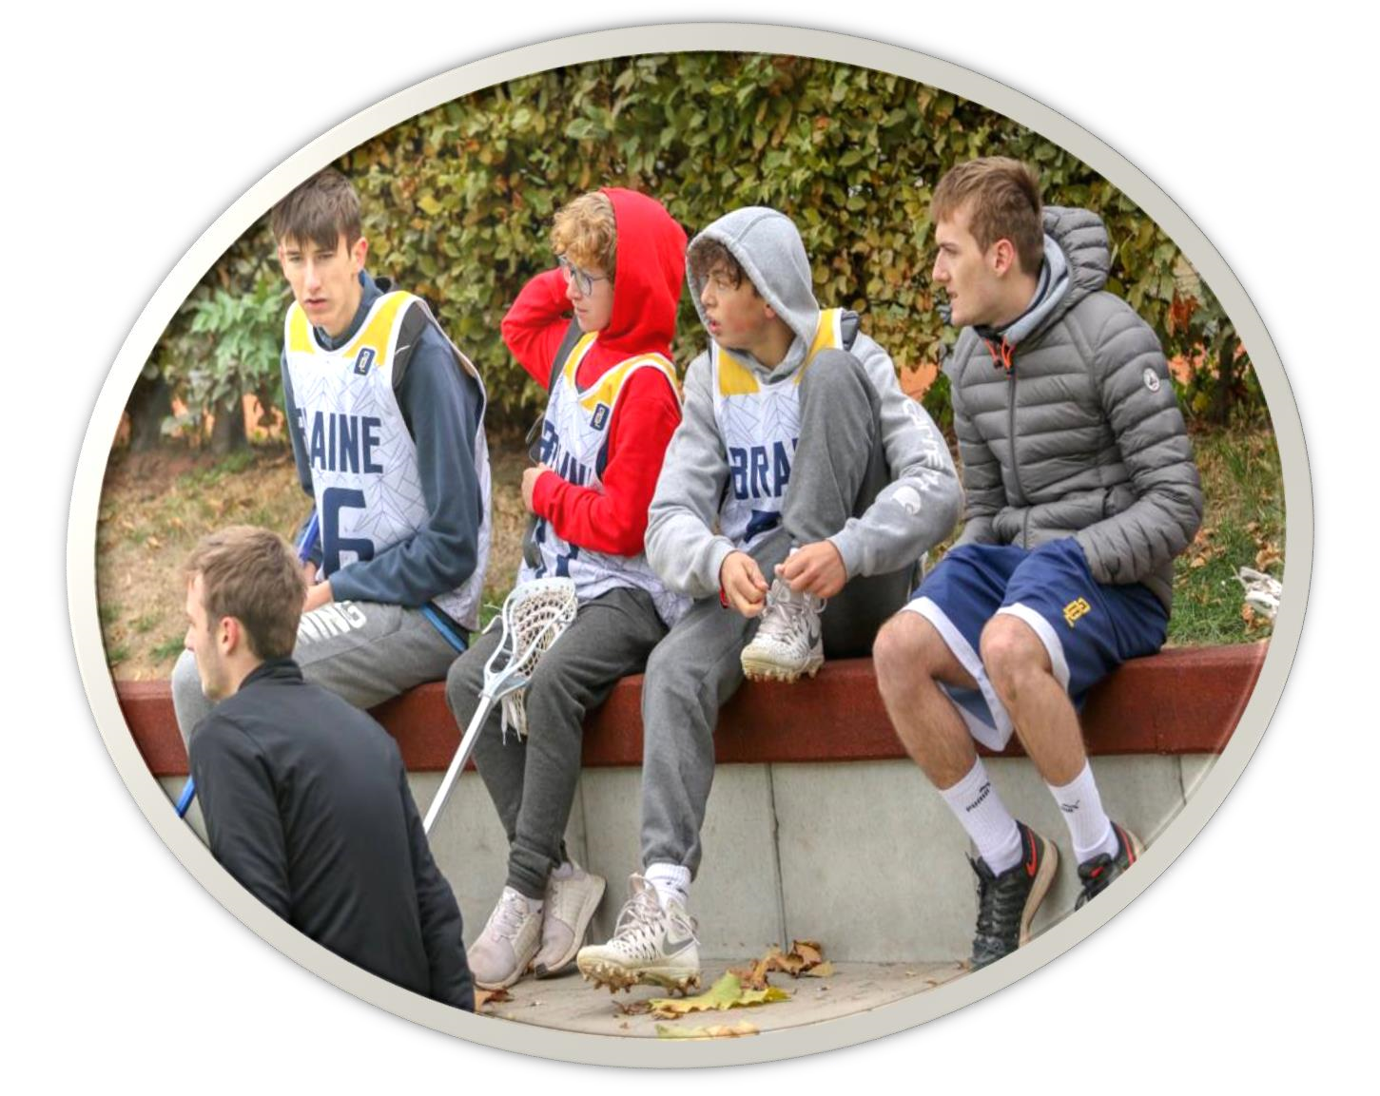

What is Poor practice?
Poor practice is behaviour which does not meet the standards set out by England Lacrosse Such behaviour could be intentional or accidental.

This includes behaviour which contravenes.
England Lacrosse Code of Conduct
England Lacrosse Equality Policy
England Lacrosse Safeguarding and Protecting Young People in Lacrosse Policy, Procedures, and Good Practice Guidance

All members of the Lacrosse Community have a responsibility to identify and address behaviour that contravenes the above guidance and policy. England Lacrosse offer advice and support in dealing with these issues.

Ignored or repetitive poor practice, if unchallenged, can have a negative impact on young people and should not be underestimated.

Behaviour and Culture

Child abuse
Child abuse can and does occur inside and outside the family environment. It is not always easy, even for experts, to determine where abuse has occurred. Staff and volunteers in lacrosse are not experts in identifying abuse. However, all adults working within lacrosse have a duty of care to be vigilant and respond appropriately to suspicions of poor practice, abuse or bullying. This does not mean that it is your responsibility to decide if a situation is poor practice, abuse or bullying but it is your responsibility to report your concerns.

What is abuse?
Abuse is a form of maltreatment of a child. Somebody may abuse or neglect a child by inflicting harm or by failing to act to prevent harm. Children may be abused in a family or in an institutional or community setting by those known to them or, more rarely by others. Abuse can take place online, or technology may be used to facilitate offline. Children may be abused by an adult or adults, or another child or children.

There are four recognised forms of child abuse (Definitions taken from Working Together 2018)

1. Emotional abuse
The persistent emotional maltreatment of a child such as to cause severe and adverse effects on the child’s emotional development. It may involve conveying to children that they are worthless, unloved, and inadequate or valued only as far as they meet the needs of another person. It may include not giving the child the opportunities to express their views, deliberately silencing them or ‘making fun’ of what they say or how they communicate. It may feature age or developmentally inappropriate expectations being imposed on children. These may include interactions that are beyond a child’s developmental capability, as well as overprotection and limitation of exploration and learning, or preventing the child participating in normal social interaction. It may involve seeing or hearing the ill-treatment of another. It may involve serious bullying (including cyber bullying) causing children frequently to feel frightened or in danger, or the exploitation or corruption of children. Some level of emotional abuse is involved in all types of maltreatment of a child though it may occur alone.

In lacrosse situation, emotional abuse may occur when coaches, volunteers, or parents:
Provide repeated negative feedback.
Repeatedly ignore a young player’s efforts to progress.
Repeatedly demand performance levels above the young player’s capability
Over emphasise “a win at all costs” ethic.

- Abuse by neglect
The persistent failure to meet a child’s basic physical and/or psychological needs, likely to result in the serious impairment of the child’s health or development. Neglect may occur during pregnancy because of maternal substance abuse. Once a child is born, neglect ay involve a parent or carer failing to:

- Provide adequate food, clothing, and shelter (including exclusion from home or abandonment)
- Protec a child from physical and emotional harm or danger
- Ensure adequate supervision (including the use of inadequate caregivers)
- Ensure access to appropriate medical care or treatment.

It may also include neglect of, or unresponsiveness to, a child’s basic emotional needs.

In a lacrosse situation, neglect may occur when:
Young players are left alone without proper supervision.
A young player is exposed to unnecessary heat or cold.
A young player is not provided with necessary fluids for rehydration.
A young player is exposed to an unacceptable risk of injury.

- Physical abuse
A form of abuse which may involve hitting, shaking, throwing, poisoning, burring, or scalding, drowning, suffocating, or otherwise causing physical harm to a child. Physical harm may also be caused when a parent or carer fabricates the symptoms of, or deliberately induces illness in a child. It also occurs when young people are given alcohol, or inappropriate drugs, or there is a failure to supervise their access to these substances.

In a lacrosse situation, physical abuse may also occur when:
Young players are exposed to exercise/training which disregards the capacity of the player’s immature and growing body.
Young players are exposed to overplaying, overtraining, or fatigue.
Any person exposes young players to alcohol and gives them the opportunity to drink alcohol below the legal age or fail to supervise access to alcohol.
Young players are provided with or encouraged to take prohibited substances including performance-enhancing drugs or recreational drugs.

4. Sexual abuse
Sexual abuse involves forcing or enticing a child or young person to take part in sexual activities, not necessarily involving a high level of violence whether the child is or is not aware of what is happening. The activities may involve physical contact, including penetration (for example rape or oral sex) or non-penetrative acts such as masturbation, kissing, rubbing, and touching outside of clothing. They may include non-contact activities, such as involving children in looking at, or in the production of, sexual online images, watching sexual activities, or encouraging children to act in sexually inappropriate ways, or grooming a child in preparation for abuse.
Adult males do not solely perpetrate sexual abuse. Women can also commit acts of sexual abuse, as can other children.

In a lacrosse situation, sexual abuse may occur when:
An adult uses the context of a training session to touch young people in an inappropriate sexual way.
Coaches, managers, or volunteers use their position of power and authority to coerce young players into a sexual relationship.
Coaches or managers imply better progression of the player in return for sexual favours.
Technology or social media is used inappropriately to groom a young person e.g., sexting.

5. Bullying
Bullying is not included in Government guidance as a type of child abuse; however, it may be a significant factor in other types of child abuse and does have equally detrimental consequences for a child. Bullying is anything that is done with the intention of hurting or intimidating, frightening, or upsetting another person and is often peer to peer. Bullying is not always physical but results in distress to the victim. Instances of bullying can occur not only between young people but also from adults to young people.

Bullying can be:
Emotional - persistently being unfriendly, excluding, tormenting threatening gestures.
Physical - Pushing, kicking, hitting, punching or any use of violence.
Racist - Racial taunts, graffiti, gestures
Sexual - Unwanted physical contact or sexually abusive comments
Homophobic - Because of, or focusing on, the issue of sexuality.
Verbal - Name-calling, sarcasm, spreading rumours, teasing or banter.
Cyber - All areas of the internet (including social networking sites), email and text messaging misuse of technology i.e., manipulation of digital images contact.

It should be noted that bullying may occur through face-to-face.
Bullying if performed by adults towards a child, will be deemed as abuse.

Any illegal acts of bullying should be reported through England Lacrosse’s reporting procedures and will be referred to external agencies for consideration.

In a lacrosse situation, bullying may occur when:

- Young players are deliberately excluded from activities by coaches or other player young players are unreasonably forced to do things that they do not want to do.
- Young players are subjected to physical, verbal, emotional or sexual abuse.
- Young players are subjected to abuse due to their race or sexuality.
- Young officials, coaches or players are subjected to verbal abuse via social networking sites.

Any illegal acts of bullying should be reported through England Lacrosse’s reporting procedures and will be referred to external agencies for consideration.

England Lacrosse offer anti-bullying guidance – available on-line

Signs and Indicators
Indications that a young person may be being abused can be difficult to recognise even for the experienced. Some young people may have additional vulnerability due to their disability, language, culture, sexual orientation or because they perform in an elite environment.

Here are signs and indicators, which could alert you to the fact that a child might be being abused, and these include:
This list is not exhaustive and the presence of one or more of these symptoms is not proof that abuse has taken place, but it should raise concerns.

Changes in behaviour can be caused by changes at home or school, for example bereavement. Parents need to inform coaches and welfare officer/trusted club officials if this is the case as a child’s behaviour may be affected.

If in doubt, seek advice from your Welfare Officer or EL Lead Safeguarding Consultant.

• | Unexplained bruising or injury particularly in unusual places
• | An injury for which the explanation is inconsistent
• | Unexplained sudden changes in behaviour (i.e., withdrawing, quiet, sudden outbursts of temper or emotion)
• | Inappropriate sexual awareness, language, or engaging in sexually explicit behaviour
• | Is being prevented from socialising with other young people or has difficulty making friends
• | Is distrustful of adults, particularly those with whom a close relationship would normally be expected, (i.e., parents, coach, family friend)
• | Displays variations in eating patterns (i.e., overeating or loss of appetite)
• | Loss of weight for no apparent reason (the child may be trying to make himself/herself less sexually attractive)
• | The young person becomes increasingly dirty or unkempt
• | Something another young person has said which suggests a young person is being abused
• | The young person describes an act or behaviour that is abusive.
• | Does not want to attend training or club activities
• | Changes their usual routine
• | Begins being disruptive during sessions
• | Becomes withdrawn, anxious, or lacking in confidence
• | Has possessions “go missing”
• | Becomes aggressive, disruptive, or unreasonable
• | Starts stammering
• | Attempts or threatens suicide or runs away
• | Cries themselves to sleep at night or has nightmares
• | Has unexplained cuts or bruises
• | Is hungry (money/lunch has been stolen)
• | Is bullying other young people or siblings
• | Stops eating
• | Is frightened to say what is wrong.

This list is not exhaustive and the presence of one or more of these symptoms is not proof that abuse has taken place but should raise concerns.

Changes in behaviour can be caused by changes at home or school, for example bereavement. Parents need to inform coaches and welfare officer/trusted club officials if this is the case as a child’s behaviours may be affected.

If in doubt, seek advice from your Welfare Officer or EL Lead Safeguarding Consultant

It is NOT your responsibility to decide if a situation is poor practice, abuse or bullying, but it IS your responsibility to report your concerns to the Club Welfare Officer.

It is important to create a safe environment for all young people where they can be heard, and their concerns will be taken seriously.

See England Lacrosse’s Reporting Procedures for more information raise.

