SAFEGUARDING ADULTS' POLICY AND PROCEDURES

INTRODUCTION

England Lacrosse (EL) is committed to creating and maintaining a safe and positive environment and accepts responsibility to safeguard the welfare of all adults involved in Lacrosse in accordance with the Care Act 2014 and in partnership with the Lacrosse Community.

England Lacrosse Safeguarding Adults’ Policy and Procedures apply to anyone over the age of 18 involved in Lacrosse. The Safeguarding Adults Policy applies to all employees of England Lacrosse and each member of the Lacrosse Community. The Safeguarding Adults Policy sits alongside all other EL policies and regulations including, but not limited to, the Code of Ethics and Behaviour.

Definitions of the Lacrosse Community

England Lacrosse defines The Lacrosse Community as all individuals, clubs, associations, and other organisations involved in any capacity in the game of lacrosse, whether they are members of England Lacrosse or not. For the avoidance of doubt, this includes all players and anyone working within lacrosse (in a paid or voluntary capacity, and whether as an employee or on a self-employed or other work basis) including all coaches, umpires, referees, and other officials.
Parents and spectators at Lacrosse events are also deemed members of the Lacrosse
Community, as are Commercial Partners.

Index: | Page
Principles | 2 - 3
Guidance and Legislation | 4
Definitions | 4
Types of Abuse and Neglect | 6
Signs and Indications of Abuse | 6 - 8
What to do if you have a concern | 9
How to Record a Disclosure | 10
Safeguarding Adults Flow Chart | 11
Roles and Responsibilities | 12
Good Practice, Poor Practice and Abuse | 13-14
Relevant policies | 15
Further Information | 15
Appendix 1 – Legislation and Government Initiatives | 16
Appendix 2 – Useful Contacts | 17

Principles

The guidance given in the policy and procedures is based on the following principles:

The six principles of adult safeguarding

The Care Act sets out the following principles that should underpin safeguarding of adults.

Empowerment
People being supported and encouraged to make their own decisions
and informed consent.
“I am asked what I want as the outcomes from the safeguarding process,
and these directly inform what happens.”

Prevention
It is better to act before harm occurs.
“I receive clear and simple information about what abuse is, how to
recognise the signs and what I can do to seek help.”

Proportionality
The least intrusive response appropriate to the risk presented.
“I am sure that the professionals will work in my interest, as I see them,
and they will only get involved as much as needed.”

Protection
Support and representation for those in greatest need.
“I get help and support to report abuse and neglect. I get help so that I
can take part in the safeguarding process to the extent to which I
want.”

Partnership
Local solutions through services working with their communities. Communities have a part to play in preventing, detecting, and reporting neglect and abuse.
“I know that staff treat any personal and sensitive information in
confidence, only sharing what is helpful and necessary. I am confident
that professionals will work together and with me to get the best result for
me.”

Accountability
Accountability and transparency in delivering safeguarding.
“I understand the role of everyone involved in my life and so do they.”

All adults, regardless of age, ability or disability, gender, race, religion, ethnic origin, sexual orientation, marital or gender status have the right to be protected from abuse and poor practice and to participate in an enjoyable and safe environment.

England Lacrosse will seek to ensure that our sport is inclusive and make reasonable adjustments for any ability, disability, or impairment, we will also commit to continuous development, monitoring, and review

The rights, dignity and worth of all adults will always be respected.
We recognise that ability and disability can change over time, such that some adults may be additionally vulnerable to abuse, for example those who have a dependency on others or have different communication needs.
We recognise that a disabled adult may or may not identify themselves or be identified as an adult ‘at risk’.

We all have a shared responsibility to ensure the safety and well-being of all adults and will act appropriately and report concerns whether these concerns arise within lacrosse i.e., inappropriate behaviour of a coach or umpire, or in the wider community.

All allegations will be taken seriously and responded to quickly in line with England Lacrosse Safeguarding Adults Policy and Procedures.
England Lacrosse recognises the role and responsibilities of the statutory agencies in safeguarding adults and is committed to complying with the procedures of the Local Safeguarding Adults Boards.

Guidance and Legislation

The practices and procedures within this policy are based on the principles contained within UK legislation and Government Guidance and have been developed to complement the
Safeguarding Adults Boards policy and procedures, and take the following into consideration:

      - The Care Act 2014
      - The Protection of Freedoms Act 2012
      - Domestic Violence, Crime and Victims (Amendment) Act 2012
      - The Equality Act 2010
      - The Safeguarding Vulnerable Groups Act 2006
      - Mental Capacity Act 2005
      - Sexual Offences Act 2003
      - The Human Rights Act 1998
      - The Data Protection Act 1994 and 1998

Definitions

To assist working through and understanding this policy a number of key definitions need to be explained:

Adult at Risk

Is a person aged 18 or over who is in need of care and support regardless of whether they are receiving them, and because of those needs are unable to protect themselves against abuse or neglect? In recent years there has been a marked shift away from using the term ‘vulnerable’ to describe adults potentially at risk from harm or abuse.

Abuse is a violation of an individual’s human and civil rights by another person or persons. See section 5 for further explanations.

Adult is anyone aged 18 or over.

Adult safeguarding is protecting a person’s right to live in safety, free from abuse and neglect.

Capacity refers to the ability to plan at a particular time, for example when under considerable stress. The starting assumption must always be that a person has the capacity to decide unless it can be established that they lack capacity (MCA 2005).

Types of Abuse and Neglect - Definitions from the Care Act 2014

This is not intended to be an exhaustive list but an illustrative guide as to the sort of behaviour or issue which could give rise to a safeguarding concern.

Self-neglect
This covers a wide range of behaviour: neglecting to care for one’s personal hygiene, health or surroundings and includes behaviour such as hoarding.

In lacrosse this could be a player whose appearance becomes unkempt, does not wear suitable sports kit and deterioration in hygiene.

Modern Slavery
Encompasses slavery, human trafficking, forced labour and domestic servitude. Traffickers and slave masters use whatever means they have at their disposal to coerce, deceive, and force individuals into a life of abuse, servitude and inhumane treatment.

In lacrosse you may notice that a participant in a team has been missing from practice sessions and is not responding to reminders from team members or coaches.

Domestic Abuse
Including psychological, physical, sexual, financial, and emotional abuse. It also includes so called 'honour' based violence. Sport may notice a power imbalance between a participant and a family member.

This could be a participant with Downs syndrome may be looking quiet and withdrawn when their sibling comes to collect them from sessions, in contrast to their personal assistant whom they greet with a smile.

Discriminatory
Discrimination is abuse which centres on a difference or perceived difference particularly with respect to race, gender, or disability or any of the protected characteristics of the Equality Act.

This could be the harassing of a club member because they are or are perceived to be transgender.

Organisational Abuse
Including neglect and poor care practice within an institution or specific care setting such as a hospital or care home, for example, or in relation to care provided in one’s own home. This may range from one off incidents to on-going ill-treatment. It can be through neglect or poor professional practice because of the structure, policies, processes, and practices within an organisation.

In lacrosse, this could be training without a necessary break.

Physical Abuse
Includes hitting, slapping, pushing, kicking, misuse of medication, restraint, or inappropriate sanctions.

This could be a coach intentionally striking a player.

Sexual Abuse
Including rape, indecent exposure, sexual harassment, inappropriate looking or touching, sexual teasing or innuendo, sexual photography, subjection to pornography or witnessing sexual acts, indecent exposure and sexual assault or sexual acts to which the adult has not consented or was pressured into consenting.

This could be a fellow player who sends unwanted sexually explicit text messages to a learning-disabled adult they are training alongside.

Financial or Material Abuse
Including theft, fraud, internet scamming, coercion in relation to an adult’s financial affairs or arrangements, including in connection with wills, property, inheritance or financial transactions, or the misuse or misappropriation of property, possessions, or benefits.

This could be someone taking equipment from a player with dementia.

Neglect
Including ignoring medical or physical care needs, failure to provide access to appropriate health social care or educational services, the withholding of the necessities of life, such as medication, adequate nutrition, and heating.

This could be a coach not ensuring players have access to water.

Emotional or Psychological Abuse
This includes threats of harm or abandonment, deprivation of contact, humiliation, blaming, controlling, intimidation, coercion, harassment, verbal abuse, isolation or withdrawal from services or supportive networks.

This could be a player threatening another player with physical harm and persistently blaming them for poor performance.

Not included in the Care Act 2014 but also relevant:

Cyber Bullying
Cyber bullying occurs when someone repeatedly makes fun of another person online or repeatedly picks on another person through emails or text messages, or uses online forums with the intention of harming, damaging, humiliating, or isolating another person. It can be used to carry out many different types of bullying (such as racist bullying, homophobic bullying, or bullying related to special educational needs and disabilities) but instead of the perpetrator carrying out the bullying face-to-face, they use technology to do it.

Forced Marriage
Forced marriage is a term used to describe a marriage in which one or both parties are married without their consent or against their will. A forced marriage differs from an arranged marriage, in which both parties’ consent to the assistance of a third party in identifying a spouse.

The Anti-Social Behaviour, Crime and Policing Act 2014 make it a criminal offence to force someone to marry.

Mate Crime
A ‘mate crime’ as defined by the Safety Net Project is ‘when vulnerable people are befriended by members of the community who go on to exploit and take advantage of them. It may not be an illegal act but still has a negative effect on the individual.’ Mate Crime is carried out by someone the adult knows and often happens in private. In recent years there have been many Serious Case Reviews relating to people with a learning disability who were murdered or seriously harmed by people who purported to be their friend.

Radicalisation
The aim of radicalisation is to attract people to their reasoning, inspire new recruits and embed their extreme views and persuade vulnerable individuals of the legitimacy of their cause. This may be direct through a relationship, or through social media.

Signs and indicators of abuse and neglect

Abuse can take place in any context and by all manner of perpetrator. Abuse may be inflicted by anyone in the lacrosse environment who a player meets. Or club / association members, umpire, volunteers, or coaches may suspect that a player is being abused or neglected outside of the lacrosse setting. There are many signs and indicators that may suggest someone is being abused or neglected, these include but are not limited to:

- Unexplained bruises or injuries – or lack of medical attention when an injury is present.

- Person has belongings or money going missing.

- Person is not attending / no longer enjoying their sessions.

- Someone losing or gaining weight / an unkempt appearance.

- A change in the behaviour or confidence of a person.

- They may self-harm.

- They may have a fear of a group or individual.

- They may tell you / another person they are being abused – i.e., a disclosure.

What to do if you have a concern or someone raises concerns with you.

You may become aware that abuse or poor practice is taking place, suspect abuse or poor practice may be occurring or be told about something that may be abuse or poor practice and you must report this to your organisations Welfare Officer in the first instance. In their absence report to the EL Lead Safeguarding Consultant or, if you are concerned someone is in immediate danger, contact the police straight away.

It is important when considering your concern that you also consider the needs and wishes of the person at risk, considering the nature of the alert, more information on this is given in Appendix 1 ‘The Legislative Framework’.

How to Record a Disclosure

Make a note of what the person has said using his or her own words as soon as practicable. Complete an Incident Form and submit to your organisation Welfare Officer or EL Lead Safeguarding Consultant

If it does not increase the risk to the individual, you should explain to them that it is your duty to share your concern with your Welfare Officer or EL Lead Safeguarding Consultant.

Describe the circumstances in which the disclosure came about.

Take care to distinguish between fact, observation, allegation and opinion. It is important that the information you have is accurate.

Be mindful of the need to be always confidential, this information must only be shared with your Welfare Officer or EL Lead Safeguarding Consultant and others on a need-to-know basis.

If the matter is urgent and relates to the immediate safety of an adult at risk, then contact the police immediately.

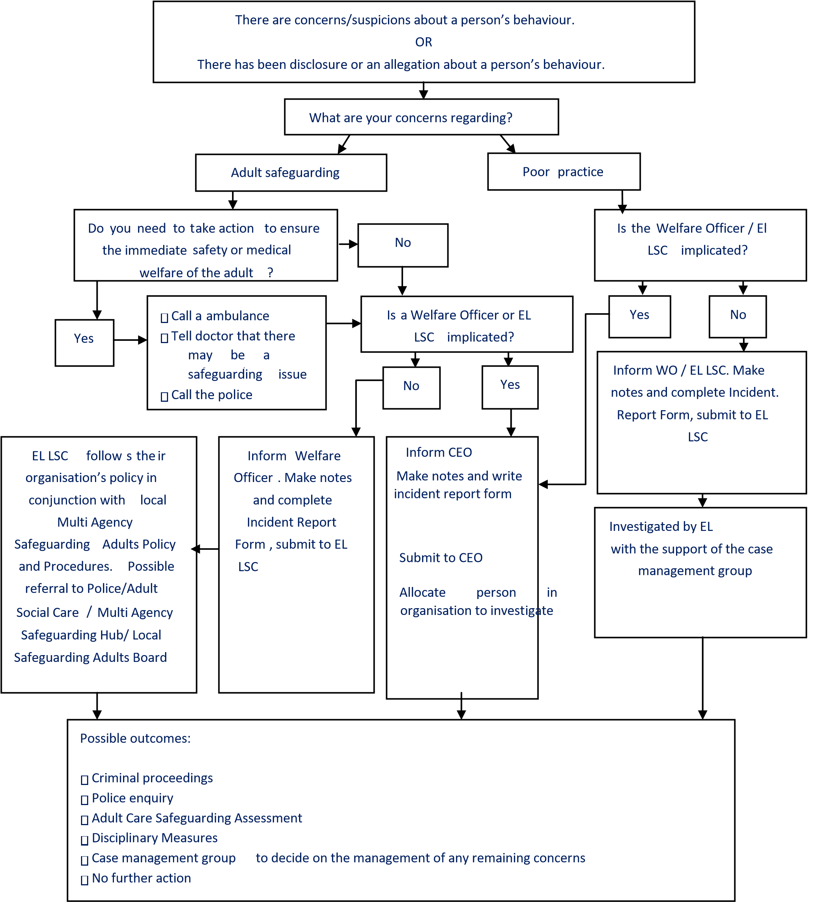
EL LSC – England Lacrosse Lead Safeguarding Consultant
EL CEO – England Lacrosse Chief Executive Officer

Remember to involve the adult at risk throughout the process wherever possible and gain consent for any referrals to social care if the person has capacity

Roles and responsibilities of those within Lacrosse

England Lacrosse is committed to having the following in place:

A Safeguarding Lead to produce and disseminate guidance and resources to support the policy and procedures.

A clear line of accountability within the organisation for work on promoting the welfare of all adults.

Procedures for dealing with allegations of abuse or poor practice against members of staff and volunteers.

A Case Management Group that effectively deals with issues, manages concerns and refers to a disciplinary panel where necessary i.e., where concerns arise about the behaviour of someone within Lacrosse

A Disciplinary Panel will be formed as required for a given incident, if appropriate and should a threshold be met.

Arrangements are in place to work effectively with other organisations to safeguard and promote the welfare of adults, including arrangements for sharing information.

Appropriate whistle blowing procedures and an open and inclusive culture that enables safeguarding and equality and diversity issues to be addressed.

Good practice, poor practice, and abuse Introduction

It can be difficult to distinguish poor practice from abuse, whether intentional or accidental.

It is not the responsibility of any individual involved in lacrosse to make judgements regarding whether abuse is taking place, however, all members of the lacrosse Community have the responsibility to recognise and identify poor practice and potential abuse, and act on this if they have concerns.

Good practice

EL expects that all individuals working with adult players:

- Adopt and endorse the England Lacrosse Codes of Ethics and Behaviour (Respect).

- Conduct themselves in line with this policy and report and any concerns.

Everyone should:
Aim to make the experience of lacrosse fun and enjoyable.

Promote fairness and playing by the rules.

Not tolerate the use of prohibited or illegal substances.

Treat all adults equally and preserve their dignity; this includes giving more and less talented members of a group similar attention, time, and respect.

Coaches and those working directly with adults at risk should:

Respect the developmental stage of each player and not risk sacrificing their welfare in a desire for team or personal achievement.

Ensure that the training intensity is appropriate to the physical, social, and emotional stage of the development of the player.

Work with adults at risk, medical adviser, and their carers (where appropriate) to develop realistic training and competition schedules which are suited to the needs and lifestyle of the athlete, not the ambitions of others such as coaches, team members, parents or carers.

Build relationships based on mutual trust and respect, encouraging adults at risk to take responsibility for their own development and decision-making.

When working with adults at risk:

Avoid coaching sessions or meetings where a coach and an individual athlete are completely unobserved.

Avoid unnecessary physical contact with people. Physical contact (touching) can be appropriate so long as:

- It is neither intrusive nor disturbing.
- The athlete’s permission has been openly given.
- It is delivered in an open environment.
- It is needed to demonstrate during a coaching session.

Maintain a safe and appropriate relationship with players and avoid forming intimate relationships with players you are working with as this may threaten the position of trust and respect present between player and coach.

- Be an excellent role model by maintaining appropriate standards of behaviour.

- Gain the adult at risk consent and, where appropriate, the consent of relevant carers, in writing, to administer emergency first aid or other medical treatment if the need arises.

- Be aware of medical conditions, disabilities, existing injuries and medicines being taken and keep written records of any injury or accident that occurs, together with details of treatments provided.

- Arrange that someone with current knowledge of emergency first aid is available always.

- Gain written consent from the correct people and fill out relevant checklists and information forms for travel arrangements and trips. This must be the adult themselves if they have capacity to do so.

Poor practice

The following are regarded as poor practice and should be avoided:

- Unnecessarily spending excessive amounts of time alone with an individual adult.
- Engaging in rough, physical or sexually provocative games, including horseplay.
- Allowing or engaging in inappropriate touching of any form.
- Using language that might be regarded as inappropriate by the adult and which may be hurtful or disrespectful.
- Making sexually suggestive comments, even in jest.
- Reducing an adult to tears as a form of control.
- Letting allegations made by an adult go un-investigated, unrecorded, or not acted upon.
- Taking an adult at risk alone in a car on journeys, however short.
- Inviting or taking an adult at risk to your home or office where they will be alone with you.
- Sharing a room with an adult at risk.
- Doing things of a personal nature that adults at risk can do for themselves.

Note: At times it may be acceptable to do some of the above. In these cases, to protect both the adult at risk and yourself, seek written consent from the adult at risk and, where appropriate, their careers and ensure that your WO or EL Lead Safeguarding Consultant is aware of the situation and gives their approval.

If, during your care, an adult at risk suffers any injury, seems distressed in any manner, appears to be sexually aroused by your actions, or misunderstands/misinterprets something you have done, report these incidents as soon as possible to another adult in the organisation and make a brief written note of it.

Relevant Policies - This policy should be read in conjunction with the following policies:

Whistle Blowing
Transgender Policy
Equality Policy
Code of Ethics and Behaviour (Respect)

Further Information
Policies, procedures and supporting information are available on the England Lacrosse website:
www.Englandlacrosse.co.uk

Lead Safeguarding Consultant – Karen Hughes
Email: Safeguarding@Englandlacrosse.co.uk
Tel: 07785763620

Review date
This policy will be reviewed every three years or sooner in the event of legislative changes or revised policies and best practice.

Appendix 1 Legislation and Government Initiatives

Sexual Offences Act 2003
http://www.legislation.gov.uk/ukpga/2003/42/contents
The Sexual Offences Act introduced a number of new offences concerning vulnerable adults and children. www.opsi.gov.uk

Mental Capacity Act 2005
http://www.legislation.gov.uk/ukpga/2005/9/introduction
Its general principle is that everybody has capacity unless it is proved otherwise, that they should be supported to make their own decisions, that anything done for or on behalf of people without capacity must be in their best interests and there should be least restrictive intervention.
www.dca.gov.uk

Safeguarding Vulnerable Groups Act 2006 http://www.legislation.gov.uk/ukpga/2006/47/contents
Introduced the new Vetting and Barring Scheme and the role of the Independent Safeguarding Authority. The Act places a statutory duty on all those working with vulnerable groups to register and undergo an advanced vetting process with criminal sanctions for non-compliance.
www.opsi.gov.uk

Deprivation of Liberty Safeguards https://www.gov.uk/government/collections/dh-mental-capacity-act-2005-deprivation-of-
libertysafeguards
Introduced into the Mental Capacity Act 2005 and came into force in April 2009. Designed to provide appropriate safeguards for vulnerable people who have a mental disorder and lack the capacity to consent to the arrangements made for their care or treatment, and who may be deprived of their liberty in their best interests in order to protect them from harm.

Disclosure & Barring Service 2013
https://www.gov.uk/government/organisations/disclosure-and-barring-service/about
Criminal record checks: guidance for employers - How employers or organisations can request criminal records checks on potential employees from the Disclosure and Barring Service (DBS).
www.gov.uk/dbs-update-service

The Care Act 2014 – statutory guidance
http://www.legislation.gov.uk/ukpga/2014/23/introduction/enacted
The Care Act introduces new responsibilities for local authorities. It also has major implications for adult care and support providers, people who use services, carers and advocates. It replaces No Secrets and puts adult safeguarding on a statutory footing.

Making Safeguarding Personal Guide 2014 http://www.local.gov.uk/documents/10180/5852661/Making+Safeguarding+Personal++Guide+ 2014/4213d016-2732-40d4-bbc0-d0d8639ef0df
This guide is intended to support councils and their partners to develop outcomes-focused, person-centred safeguarding practice.

Appendix 2 Useful contacts

England Lacrosse
Lead Safeguarding Consultant – Karen Hughes

Email: safeguarding@Englandlacrosse.co.uk
Tel: 07785763620

Local Authority Safeguarding Lead (if policy is used by a CSP or club)

Name:
Email:
Telephone:

Police contact Name:
Email:
Telephone:

Ann Craft Trust - Safeguarding Adults in Sport and Activity:
Website: www.anncrafttrust.org
Email: Ann-Craft-Trust@nottingham.ac.uk
Telephone: 0115 951 5400

